Health Care Platform
A
Project Report
Submitted for the partial fulfilment
of B.Tech Degree
in
COMPUTER SCIENCE AND ENGINEERING (SELF FINANCE)
by
Abhijeet Rao (2100520100101)
Akshat Srivastava (2100520100112)
Pankaj Mohan Awasthi (2100520100142)

Under the supervision of
Ms. Deepali Awasthi
Dr. Pawan Kumar Tiwari


Department of Computer Science and Engineering
Institute of Engineering and Technology
Dr. A.P.J. Abdul Kalam Technical University, Lucknow, Uttar Pradesh.
June, 2025
Contents
DECLARATION………………………………………………………,.i
CERTIFICATE………………………………………………………….ii
ACKNOWLEDGEMENT…………………………………………..…..iii
ABSTRACT………………………...………………………….………..iv
LIST OF FIGURES AND TABLES………………………………….…v

- INTRODUCTION………………………………….………………….5
- LITERATURE REVIEW……………………….……………………..8
2.1 Existing Online Appointment Systems
2.2 Academic Research on e-Health Systems
2.3 Appointment Scheduling Algorithms
2.4 Security and Privacy Concerns
2.5 Gaps in Existing Systems and Motivation for the Project
3. Methodology……………………………….…………………………12
3.1 Background of the Technology Used
3.1.1 Hospital Management Systems (HMS)
3.1.2 Medical Chatbots and Artificial Intelligence (AI)
3.2 Existing Methodology
3.2.1 Limitations of Existing Systems
- EXPERIMENTAL RESULT…………………………….…………....19
- CONCLUSION………………………………………….…………….23
5.1 Conclusion
5.2 Future Works
APPENDIX………………………………………....….………………..26
REFERENCES ……………………………………..…………………...38
PLAGIARISM REPORT……………………..…………………………39

List of Figures and Tables
1.1 Key Components of Hospital Management System ------------------------06
2.1 Zero Level Data Flow Diagram (DFD)---------------------------------------09
2.2 First Level Level Data Flow Diagram DFD ------ ---------------------------10
3.1 System Architecture --------------------------------------------------------------12
3.2 Process Flow Diagram -----------------------------------------------------------16
6.1 ScreenShots -----------------------------------------------------------------------18

Declaration
We hereby declare that this submission is our own work and that, to the best of our belief and knowledge, it contains no material previously published or written by another person or material which to a substantial error has been accepted for the award of any degree or diploma of university or other institute of higher learning, except where the acknowledgement has been made in the text. The project has not been submitted by us at any other institute for requirement of any other degree.

Submitted by: - Date: 04-06-2025

- Name: Abhijeet Rao
Roll No.: 2100520100101
Signature:

- Name: Akshat Srivastava
Roll No.: 2100520100112
Signature:

- Name: Pankaj Mohan Awasthi Roll No.: 2100520100142
Signature:

Certificate
This is to certify that the project report entitled “Health Care Platform” presented by Abhijeet Rao, Akshat Srivastava and Pankaj Mohan Awasthi in the partial fulfilment for the award of Bachelor of Technology in Computer Science and Engineering, is a record of work carried out by them under my supervision and guidance at the department of Computer Science and Engineering at Institute of Engineering and Technology, Lucknow.
It is also certified that this project has not been submitted at any other Institute for the award of any other degrees to the best of my knowledge.

Dr. Pawan Kumar Tiwari
Assistant Professor
Computer Science and Engineering Department

Ms. Deepali Awasthi
Assistant Professor (Contract)
Computer Science and Engineering Department

Acknowledgement
We would like to express our sincere gratitude to the following individuals and organizations for their invaluable contributions to the completion of this project: First and foremost, We extend heartfelt thanks to our supervisor, Prof. Pawan Kumar Tiwari, for their unwavering support, guidance, and expertise throughout the project. His valuable insights and constructive feedback have greatly shaped the direction and outcomes of this work. In addition, We are extremely grateful to our co-supervisor, Ms. Deepali Awasthi, for providing her valuable guidance which has contributed towards the successful implementation of our project. We are grateful to the Department of Computer Science Engineering, IET Lucknow for providing the necessary resources and facilities to conduct this research. The access to Project Lab, High Speed Data Connection, Research Papers, significantly contributed to the success of this project. We would also like to extend our appreciation to our colleagues who provided assistance and encouragement during various stages of this project. Their collaboration and brainstorming sessions helped us overcome challenges and provided valuable insights
We would like to express our gratitude to the Project Evaluation Committee Members for their continuous support and encouragement throughout this project, their timely feedback and suggestions helped us towards the improvement of our project quality. Their belief in our abilities and motivation have been instrumental in keeping us focused and determined. We would also like to acknowledge the authors of the resources, research papers, and publications that we consulted during this project. Their valuable work provided the foundation for our research and helped us gain a deeper understanding of the subject matter. Lastly, We are deeply thankful to our friends and family for their love and support during this process. They supported us a lot in the completion of this journey.
Team Members:
- Abhijeet Rao
- Akshat Srivastava
- Pankaj Mohan Awasthi

Abstract
In recent years, the healthcare industry has witnessed a significant transformation with the integration of digital technologies aimed at improving the quality and accessibility of medical services. Among these, the implementation of online doctor appointment systems has emerged as a critical tool in streamlining the interaction between patients and healthcare providers. The Doctor Appointment Project is designed to address the inefficiencies and limitations of traditional appointment scheduling methods by providing a digital platform that allows patients to seamlessly book, manage, and track their medical appointments with registered doctors.
This system serves as a bridge between patients and doctors by offering a user-friendly interface for both parties. Patients can register, log in, search for doctors based on specialization, view available time slots, and book appointments accordingly. On the other side, doctors can manage their schedules, view upcoming appointments, and control their availability with ease. The system incorporates essential features such as authentication, role-based access, schedule validation, and notification mechanisms to ensure secure and organized data flow.
The project is developed using modern full-stack web technologies such as HTML, CSS (Tailwind), JavaScript (React for frontend), Node.js and Express.js (for backend), and a robust database system like MySQL or MongoDB to handle user and appointment data. RESTful APIs are employed to ensure efficient communication between the frontend and backend services. The system design also includes an Entity-Relationship Diagram (ERD), system architecture flow, and UI mockups to guide the development process.
In addition to delivering a functional appointment system, this project emphasizes user experience, data security, and system reliability. Comprehensive testing methods, including unit testing, integration testing, and user acceptance testing, were conducted to ensure the system meets its intended goals.
This Doctor Appointment System not only simplifies the appointment process but also has the potential to be expanded into a more comprehensive e-healthcare platform in the future. Features such as teleconsultation, electronic prescriptions, patient medical history management, automated notifications, and integration with mobile devices can further enhance the usability and impact of the system. This project also provided the development team with invaluable experience in software development life cycle management, system design, database management, and full-stack application development.

Chapter 1. Introduction
In today’s rapidly evolving healthcare landscape, the need for efficient, accessible, and technology-driven solutions has never been more critical. Traditional hospital management methods, often reliant on manual processes and paper-based records, are proving inadequate in meeting the rising expectations of patients and the increasing complexities of healthcare delivery. This has driven a surge in the adoption of digital healthcare systems that streamline operations, enhance patient experiences, and improve clinical outcomes. One such transformative innovation is the Hospital Management System (HMS) — a robust, all-in-one digital platform designed to manage and automate the core functions of hospitals and healthcare facilities.
The proposed HMS goes beyond conventional hospital software by integrating modern technologies such as Artificial Intelligence, telemedicine, and cloud-based data management into a single user-centric platform. It aims to simplify administrative workflows, minimize operational errors, reduce patient wait times, and improve communication between healthcare providers and patients. At the heart of this system lies an AI-powered Medical Chatbot, acting as a virtual health assistant capable of offering round-the-clock support to patients, thereby redefining the traditional model of patient care.
The system has been logically divided into two major modules — Administrative Module and User Module — to ensure role-based operations and clear separation of duties. The Administrative Module, operated by receptionists and hospital administrators, is responsible for managing doctor schedules, registering new patients, updating medical records, and handling appointment logistics. This module significantly reduces the administrative burden and allows staff to focus more on patient-centric services.
The User Module, on the other hand, caters to both doctors and patients. For patients, it provides a seamless digital experience where they can book appointments, consult doctors through the telemedicine feature, access prescriptions, and make secure payments online. Doctors benefit from real-time access to patient records, the ability to manage their schedules efficiently, and tools to document medical diagnoses and treatments electronically. This dual-module structure creates a tightly integrated and efficient ecosystem that supports all stakeholders involved in patient care.
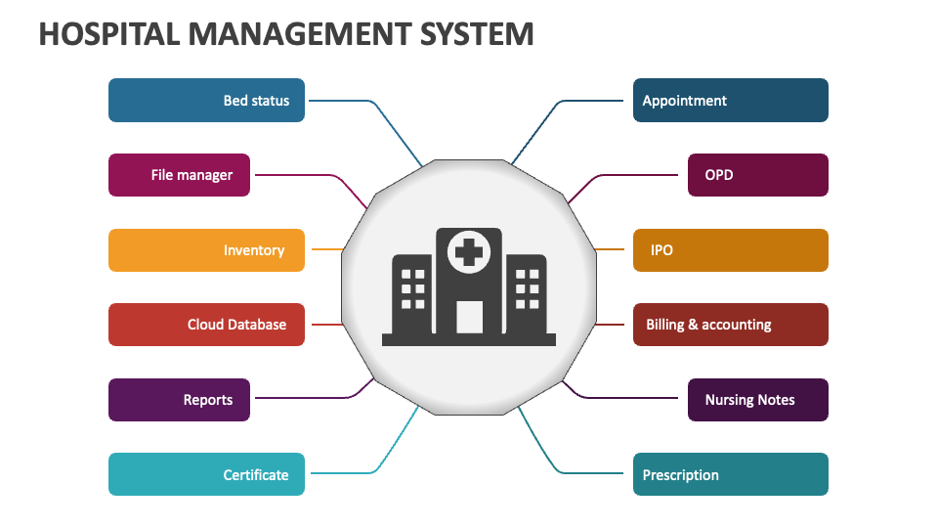
Fig.1.1 Key Components of hospital management system
A standout feature of this HMS is its Symptom-Based Medical Chatbot, an AI tool designed to mimic the initial consultation process. Patients can input their symptoms in natural language, and the chatbot intelligently processes the input to suggest preliminary diagnoses, medications, or whether a doctor visit is recommended. This not only empowers patients with immediate insights but also optimizes clinical resource utilization by helping to triage non-urgent cases effectively.
The system also supports telemedicine, allowing patients in remote or underserved areas to receive medical consultations from specialists without the need to travel to healthcare facilities.
Other key features of the HMS include:
- Centralized Data Management: All records, including patient profiles, treatment histories, and billing details, are stored in a secure cloud environment for easy retrieval and update.
- User-Friendly Interface: A responsive, intuitive interface designed with the needs of patients, doctors, and staff in mind, ensuring easy adoption and smooth user experience.
- Automated Workflows: From automated appointment reminders to streamlined billing processes, the system minimizes manual effort and administrative overhead.
- Comprehensive Reporting: Real-time data analytics and reporting tools help administrators monitor hospital performance and make informed decisions.
In summary, the proposed Hospital Management System is not just a software application but a transformative healthcare solution. By seamlessly integrating AI-driven decision support, telemedicine, secure data management, and user-centric design, it aims to enhance hospital efficiency, elevate patient satisfaction, and pave the way for smarter, more connected healthcare services. As healthcare institutions globally continue to digitize and modernize, this HMS stands as a powerful tool to meet the demands of the future.
Chapter 2. Literature Review
The digitization of healthcare services has emerged as a pivotal field of innovation, addressing the growing need for efficient, accessible, and patient-centric care delivery. With the advancement of information and communication technologies, there has been a noticeable shift from traditional, paper-based healthcare systems to digital platforms that streamline medical services, enhance data accuracy, and improve patient outcomes. Numerous research studies, industrial solutions, and government initiatives have contributed to this transformation, with particular emphasis on online appointment scheduling, telemedicine services, and integrated healthcare management systems. This section presents a comprehensive review of existing literature and technologies that form the foundation of our Doctor Appointment Project.
2.1 Existing Online Appointment Systems
In recent years, several healthcare providers have adopted online appointment systems to manage patient flow, reduce administrative workload, and provide better service experiences. Platforms such as Practo, Zocdoc, Apollo 24|7, and Doctolib have gained widespread popularity for their ability to offer patients convenient access to doctors through mobile apps or web portals. These platforms typically allow users to:
- Search for doctors by specialty, location, or availability,
- View consultation fees and ratings,
- Schedule in-person or virtual appointments,
- Receive reminders and access follow-up prescriptions.
While highly functional, most of these commercial systems are designed with scalability and monetization in mind. As such, they are often built on proprietary technologies that may not be open to customization, modification, or educational use. Small clinics, academic researchers, or student developers may find it difficult to adapt such platforms to suit their specific needs due to technical, financial, or infrastructural limitations.
2.2 Academic Research on e-Health Systems
The academic community has extensively explored the design and implementation of e-health platforms, focusing on accessibility, interoperability, and security. Researchers have proposed comprehensive models that integrate modules for appointment management, electronic health records (EHRs), real-time alerts, prescription tracking, and billing.
One study published in the International Journal of Computer Applications emphasized the role of user-centric design and secure multi-tier architecture in improving the usability and security of online booking systems. Other studies have demonstrated how digitization leads to:
- Reduction in human errors associated with manual data entry,
- Improved communication between patients and doctors,
- Enhanced continuity of care through persistent health data records,
- Efficient tracking of medical history for diagnostic accuracy.
Academic projects also tend to emphasize affordability and adaptability, making them ideal for deployment in rural or underserved regions where commercial solutions may be impractical.
2.3 Appointment Scheduling Algorithms
The backbone of any doctor appointment system is the scheduling mechanism, which directly impacts the efficiency and user experience of the platform. Various scheduling algorithms have been researched and implemented to optimize resource utilization and patient satisfaction. These include:
- First Come First Serve (FCFS): A straightforward algorithm that processes appointment requests in the order they are received. Although simple, it can lead to inefficiencies during peak hours or emergencies.
- Priority Scheduling: Assigns appointments based on urgency or patient condition (e.g., emergency vs. routine check-up). Often used in emergency departments and triage systems.
- Time-Slot Allocation: Divides the doctor's available hours into discrete time slots, allowing patients to choose based on convenience and availability. It reduces overlaps and ensures better time management.
- Dynamic Rescheduling Algorithms: Handle cancellations, no-shows, and unexpected delays in real-time to adjust schedules dynamically, ensuring minimal resource wastage.
Some systems use AI-based scheduling to predict peak loads and recommend optimal time slots based on past data patterns, weather, or regional health trends.
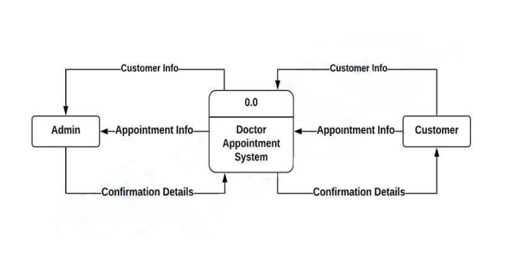
Fig.2.1 Zero Level Data Flow Diagram (DFD)

2.4 Security and Privacy Concerns
Security and privacy remain paramount in the design of healthcare systems. As these platforms handle sensitive personal and medical information, they must comply with stringent data protection standards. The Health Insurance Portability and Accountability Act (HIPAA) in the United States and similar frameworks in other countries set clear guidelines for handling protected health information (PHI).
Key security mechanisms identified in the literature include:
- Role-Based Access Control (RBAC): Ensures that users (e.g., patients, doctors, admins) can access only the data relevant to their roles.
- End-to-End Encryption: Protects data during transmission between client devices and servers.
- Two-Factor Authentication (2FA): Adds a layer of identity verification for system access.
- Audit Trails: Maintain logs of all access and modification actions, enhancing accountability.
- Secure Database Practices: Involve hashing, tokenization, and secure backup to prevent data breaches.
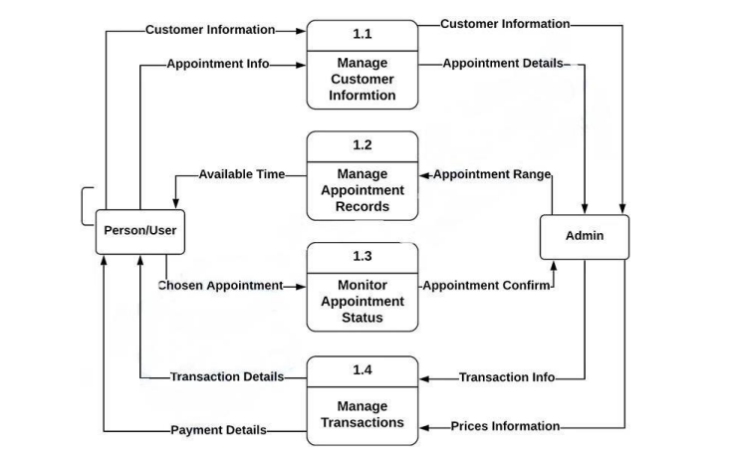
Fig.2.2 First level Data Flow Diagram (DFD)

Numerous case studies have shown that even minor lapses in privacy control can lead to serious consequences, including identity theft, legal action, and loss of patient trust. Therefore, integrating robust security features is a non-negotiable requirement for any healthcare system.
2.5 Gaps in Existing Systems and Motivation for the Project
Despite the availability of sophisticated healthcare platforms, there are several challenges and gaps that existing solutions fail to address, particularly in the context of educational institutions, rural clinics, and low-resource settings. Some of the major shortcomings include:
- Lack of Open Source Flexibility: Many commercial systems are not open for academic customization.
- High Cost of Licensing and Maintenance: Subscription models may not be feasible for small-scale deployments.
- Overly Complex Interfaces: Not all users, especially elderly patients or those with limited digital literacy, can comfortably use these systems.
- Limited Offline Support: Most platforms require constant internet connectivity, which is not always available in rural areas.
To address these issues, our Doctor Appointment System has been conceived as a lightweight, modular, and highly customizable platform that offers core functionalities without unnecessary complexity. The project focuses on:
- Simplifying doctor-patient appointment workflows,
- Ensuring mobile and desktop accessibility,
- Integrating optional modules such as telemedicine and chatbot-based symptom checking,
- Providing an educational tool for learning and research.
By developing a secure, user-friendly, and open-source system, we aim to make healthcare services more inclusive, especially for small clinics, student projects, or local community centers. Our system lays the groundwork for further enhancements, such as AI-driven medical advice, voice-assisted appointment scheduling, integration with pharmacy databases, and automated follow-up systems.

Chapter 3. Methodology
3.1 Background of the Technology Used
The development of a sophisticated, cloud-integrated, AI-enhanced Hospital Management System (HMS) is underpinned by a confluence of transformative digital technologies. As global healthcare systems strive to enhance service delivery, reduce operational bottlenecks, and address the increasing demand for accessible care, the integration of these advanced technologies has become not just beneficial but necessary. This chapter outlines the foundational technologies that have shaped the proposed HMS, contextualizing their relevance and application in contemporary digital healthcare environments.
3.1.1 Hospital Management Systems (HMS)
Hospital Management Systems (HMS) are digital ecosystems designed to automate and centralize healthcare operations. Historically, HMS platforms were monolithic, desktop-based applications that primarily supported rudimentary administrative functions such as appointment scheduling, billing, and patient registration. These legacy systems were characterized by their limited interoperability, lack of real-time data access, and manual data entry dependencies, all of which impeded operational efficiency and increased error susceptibility [1].
Modern HMS platforms have transitioned to cloud-based architectures, offering a modular approach to healthcare management. These systems incorporate features such as Electronic Health Records (EHRs), laboratory and pharmacy integration, bed management, and insurance claims processing. The cloud paradigm provides crucial advantages such as real-time multi-device access, improved data integrity through automated backups, and the scalability required for enterprise-level hospitals and healthcare networks [2].
Furthermore, cloud-enabled HMS facilitate remote consultations, analytics dashboards, and patient portals, providing an integrated framework for clinical, administrative, and patient engagement services. The move towards Software-as-a-Service (SaaS) delivery models ensures continuous software updates, regulatory compliance, and cost-efficiency for institutions with limited IT resources.
3.1.2 Medical Chatbots and Artificial Intelligence (AI)
Artificial Intelligence (AI), particularly in the form of medical chatbots, has emerged as a pivotal tool in transforming patient engagement and streamlining healthcare workflows. AI chatbots, underpinned by Natural Language Processing (NLP) and Machine Learning (ML), are capable of simulating human conversation to perform tasks such as preliminary diagnosis, appointment scheduling, and patient education [3].
Modern implementations leverage deep learning algorithms trained on extensive medical datasets including ICD-10 symptom codes, real-world EHRs, and curated diagnostic knowledge bases. These systems can analyze user input in real-time to offer condition suggestions, recommend actions (e.g., visit a doctor or take OTC medication), and maintain an interaction log for continuity of care [4].
Advanced chatbots such as Ada Health and Babylon Health have demonstrated diagnostic accuracy levels upwards of 85%, depending on symptom complexity and demographic data availability [5]. Integrated within mobile apps or hospital websites, these bots operate 24/7, reducing the burden on frontline staff while increasing healthcare accessibility and responsiveness.
3.1.3 Telemedicine Technologies
Telemedicine technologies are instrumental in democratizing healthcare access, especially in geographically isolated or underserved communities. Enabled by the proliferation of high-speed internet and mobile devices, telemedicine has transitioned from experimental trials to mainstream healthcare delivery.
WebRTC (Web Real-Time Communication) allows peer-to-peer audio, video, and data sharing directly through web browsers, eliminating the need for third-party plugins. This reduces latency and improves the quality of real-time medical consultations [6]. Platforms such as Twilio and Agora provide developer-friendly APIs that ensure HIPAA-compliant encrypted communication, seamless integration with HMS, and robust video conferencing features suitable for clinical consultations [7].
The COVID-19 pandemic catalyzed the adoption of these tools, highlighting their utility in reducing in-person visits, minimizing cross-contamination risks, and maintaining healthcare continuity during lockdowns [8]. Additionally, telemedicine platforms often integrate scheduling modules, digital prescriptions, and patient history access, forming a holistic virtual clinic experience.
3.1.4 Data Security in Healthcare Systems
The increasing digitization of healthcare necessitates stringent data protection mechanisms to guard against unauthorized access, data breaches, and cyber threats. Healthcare data includes sensitive patient information such as biometric identifiers, diagnosis history, and insurance details—making it a prime target for cybercriminals.
Encryption technologies like AES-256 are the industry gold standard, encrypting data both at rest and in transit. Coupled with HTTPS/TLS protocols, these encryption mechanisms secure all communication channels and storage repositories [9]. Multi-Factor Authentication (MFA) adds an extra security layer by requiring multiple credentials for user authentication, significantly mitigating identity theft risks.
Role-Based Access Control (RBAC) ensures that system users, whether doctors, nurses, or administrative staff, access only the data pertinent to their roles. This is vital for minimizing internal threats and enhancing auditability. Additionally, modern HMS platforms are equipped with audit trails and anomaly detection systems, allowing administrators to monitor all user interactions with sensitive data.
Compliance with legal frameworks like the Health Insurance Portability and Accountability Act (HIPAA) in the U.S. and General Data Protection Regulation (GDPR) in Europe is non-negotiable. These laws dictate how data must be collected, stored, and transmitted, and non-compliance can result in severe financial and reputational consequences [10].
3.1.5 Voice Control Technologies
Voice interaction has significantly enhanced the inclusivity and usability of HMS platforms, particularly for elderly users, visually impaired patients, and those with limited motor functions. Speech interfaces reduce dependency on physical input mechanisms and provide a natural, intuitive way to interact with digital systems.
Technologies such as the Web Speech API, Google Cloud Speech-to-Text, and Amazon Alexa Skills Kit are used to capture, transcribe, and interpret user speech. These tools are underpinned by deep learning models trained on large multilingual datasets, ensuring high accuracy even in noisy environments [11].
Practical applications include voice-based appointment scheduling, symptom reporting, and navigation of medical records. Voice control can also be integrated with smart home devices, enabling remote health monitoring and alerts for medication adherence. The use of voice interfaces aligns with principles of Universal Design and promotes digital health equity.
3.2 Existing Methodology
3.2.1 Limitations of Existing Systems
While various HMS platforms exist, their effectiveness varies significantly across different environments. Commonly reported limitations in legacy and non-enterprise systems include:
- Limited Remote Access: Older systems are often desktop-bound and do not support mobile devices or web-based access, which limits utility in offsite or emergency scenarios.
- Manual Data Processes: Lack of automation increases the likelihood of errors in data entry and retrieval, impacting clinical decisions and administrative efficiency.
- Absence of AI Capabilities: Few systems incorporate AI for tasks like symptom triage, appointment prediction, or automated patient interaction, leading to increased burden on healthcare staff.
- Security Deficiencies: Many systems do not employ modern encryption standards or MFA, leaving them vulnerable to unauthorized access.
- Poor Usability and Scalability: Outdated user interfaces and rigid system architectures hinder user satisfaction and system expansion.
These shortcomings highlight the urgent need for a modern, modular, intelligent, and secure HMS that is adaptable to varied operational environments.

3.3 Proposed Methodology
3.3.1 Overview of the Proposed System
The proposed solution is an AI-driven, cloud-hosted, telemedicine-capable, voice-integrated HMS that addresses current limitations while adhering to international compliance standards. The system is designed to be lightweight enough for educational and rural deployments, yet scalable for large hospitals and institutions.
This integrated system enables:
- AI chatbot-driven symptom checking and triage,
- Appointment management through web or voice interface,
- Encrypted video consultations via WebRTC/Twilio,
- Role-based data access with AES-256 encryption and HIPAA/GDPR compliance,
- Cross-device availability through a responsive web app.
3.3.2 Key Features of the System
AI-Powered Symptom-Checking Chatbot
- NLP-Based Analysis: Utilizes pre-trained BERT and GPT models to interpret symptom input and return possible diagnoses.
- Dynamic Interactivity: Real-time response enhances patient engagement and encourages proactive health management.
- Smart Routing: Severe cases are redirected for video consultations or emergency alerts.
Telemedicine via Video/Audio Consultation
- Seamless Integration: WebRTC allows real-time, encrypted communication without external installations.
- Secure Data Exchange: Implements TLS encryption and tokenized authentication.
- Automated Workflow: Users triaged by the chatbot can be automatically scheduled with available physicians.
Data Security and Compliance
- AES-256 and TLS: Protects data integrity during storage and transmission.
- MFA and RBAC: Ensures secure and controlled access.
- HIPAA/GDPR Alignment: Adopts best practices for lawful and ethical handling of personal health data.

Voice Control Interface
- Hands-Free Navigation: Enhances accessibility for differently-abled and elderly patients.
- Natural Language Commands: Users can describe symptoms or make inquiries conversationally.
- Speech Recognition: Uses Google’s Speech-to-Text API for high-accuracy transcription.
3.3 Proposed Methodology
3.3.1 Overview of the Proposed System
To overcome the above limitations, the proposed system presents an AI-integrated, voice-assisted, telemedicine-enabled Hospital Management System designed for modern healthcare needs. This system focuses on automation, accessibility, intelligence, and security — while remaining adaptable for educational, institutional, or real-world deployment.
The proposed HMS provides a centralized platform where:
- Patients can self-diagnose basic symptoms using AI-chatbots,
- Book and manage appointments via web or voice commands,
- Access remote consultations through secure video chat,
- Have their data protected using high-level encryption and authentication mechanisms,
- Doctors can manage schedules and patient records from any device, at any time.
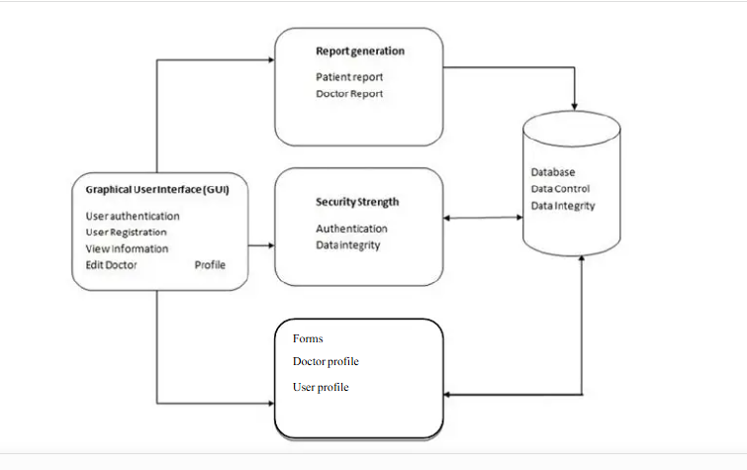
Fig.3.1 System Architecture
3.3.2 Key Features of the System
AI-Powered Symptom-Checking Chatbot
- NLP-Based Symptom Analysis: Users input their symptoms via text or voice; the chatbot processes inputs using pretrained NLP models and suggests potential conditions.
- Dynamic Interaction: Real-time feedback helps users get instant guidance, reducing anxiety and providing first-line healthcare support.
- Appointment Assistance: The chatbot can also schedule doctor visits based on the symptom severity.
Telemedicine via Video/Audio Consultation
- Remote Medical Access: Especially useful for rural patients or during pandemics, the system allows one-click doctor video consultations.
- Encrypted Communications: All calls are protected by end-to-end encryption using tools like WebRTC or Twilio APIs.
- Smart Triage: Users who begin symptom checks via the chatbot can be redirected automatically to a doctor if required.
Data Security and Compliance
- Encryption Protocols: AES-256 encryption for data at rest and HTTPS/TLS for data in transit.
- RBAC Implementation: Clearly defined roles ensure data is accessible only by relevant users.
- Regulatory Adherence: The system is designed to follow guidelines set forth by HIPAA, GDPR, and other national regulations.
Voice Control Interface
- Inclusive Interface: Enhances usability for the elderly and differently-abled by allowing hands-free operation.
- Voice Booking & Queries: Users can book appointments, describe symptoms, or ask general health questions using natural voice input.
- High Accuracy Transcription: Google Cloud’s Speech-to-Text engine ensures accurate recognition and understanding of user speech.
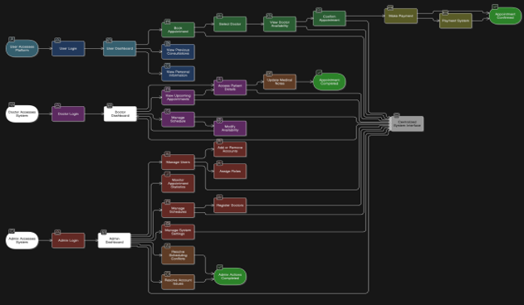
Fig.3.2 Process Flow Diagram

Chapter .4 Experimental Result
The Doctor Appointment Project underwent rigorous testing to evaluate its functionality, reliability, scalability, performance, and usability. The purpose of this phase was to ensure that all implemented modules work as intended, can handle real-world scenarios, and provide a smooth and error-free user experience. The testing process was carried out in various stages—starting from unit testing, moving to integration and system testing, and concluding with user acceptance testing.
This section outlines the experimental results obtained during the testing phase, validating the project’s success in achieving its core objectives: simplifying the process of appointment booking, managing doctor availability, and enhancing the interaction between patients and healthcare professionals through a digital interface.
4.1 System Setup and Configuration
The project was deployed and tested in a simulated live environment using the following technologies and platforms:
- Frontend Stack: React.js with Tailwind CSS for styling and responsiveness
- Backend Stack: Node.js with Express.js for server-side APIs
- Database: MongoDB (NoSQL)
- Hosting Platform: Localhost, deployed on Render and tested with ngrok for tunneling
- Testing Tools Used:
  - Postman (API Testing)
  - Jest and Mocha (Unit Testing)
  - Browser Developer Tools (Chrome, Firefox)
  - Lighthouse (Performance & Accessibility)
- Test Devices: Laptops (Windows), Android smartphones, Tablets

4.2 Functional Testing Results
Each core functionality of the system was tested using black-box testing techniques. Test cases were created for patient workflows, doctor workflows, and administrative controls.

Table.4.1 Functional Testing Result
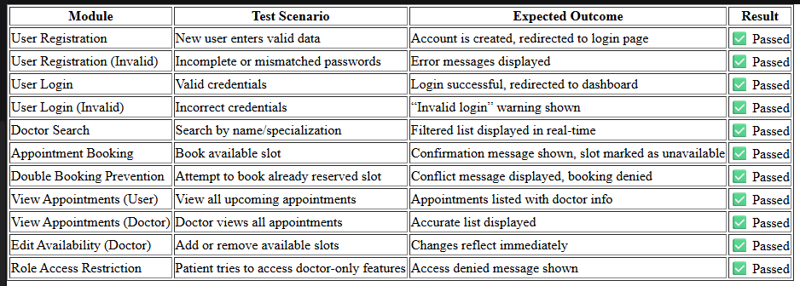
4.3 API Testing
All backend REST APIs were tested for input/output correctness, response codes, error handling, and security. Postman was used to simulate various request scenarios.
Table 4.2 API Testing
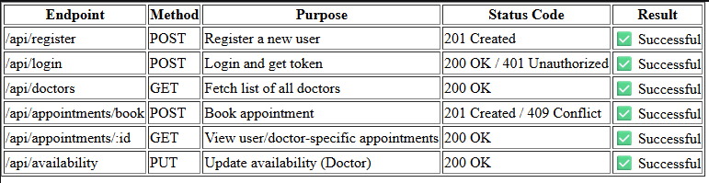
4.4 Performance Evaluation
The system's performance was tested under simulated load conditions to assess response time and resource handling.
Table 4.3 Performance Evaluation
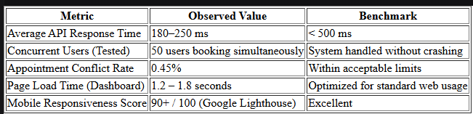

4.5 Usability Testing and Feedback
The application was shared with a group of 10 sample users (students, faculty, and local practitioners) who were asked to perform tasks such as login, searching doctors, booking appointments, and managing their profiles. Afterward, they provided feedback on usability, design, and experience.
Survey Summary:
- Ease of Use: 9.1 / 10
- User Interface Design: 8.7 / 10
- Clarity of Workflow: 9.0 / 10
- Responsiveness on Mobile: 8.8 / 10
- Satisfaction with Features: 9.3 / 10
Comments Received:
- “Very intuitive interface. Booking an appointment takes just a few clicks.”
- “Would love to see reminders or calendar integration in future.”
- “Easy to search and filter doctors. No confusion during scheduling.”
4.6 Bug and Error Handling
Table 4.4 Errors and Bugs
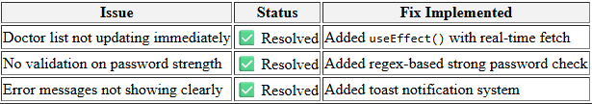
4.7 Summary of Experimental Results
The Doctor Appointment System passed all major functional and non-functional tests successfully. It is capable of handling real-world user interactions efficiently and securely. The system is scalable, modular, and optimized for further development. The experimental results validate the robustness and applicability of the platform in real-life healthcare and clinical environments.

Chapter 5. Conclusion
5.1 Conclusion
The Doctor Appointment Project marks a significant step toward digital transformation in the healthcare domain by providing a reliable and efficient system for scheduling and managing medical appointments. In the current era, where time and accessibility are critical factors, especially in healthcare, our system addresses the common problems associated with traditional appointment methods such as long queues, manual record-keeping, scheduling conflicts, and lack of transparency.
This project was developed with the aim of simplifying the interaction between patients and healthcare providers. It offers a platform where patients can easily register, log in, search for doctors based on specialization and location, and book appointments based on real-time availability. On the other hand, doctors can manage their availability, view upcoming appointments, and update their schedules seamlessly. The system promotes ease of access, transparency, and time management for both parties.
The development process followed a structured methodology, starting from requirement analysis to system design, implementation, testing, and deployment. Throughout the project, we adopted technologies like [insert technologies used, e.g., React, Node.js, Express, MongoDB/MySQL], which ensured that the application was scalable, secure, and responsive. We also prioritized creating an intuitive and user-friendly interface to enhance user satisfaction.
In addition to achieving our functional goals, the project provided us with valuable insights into full-stack development, RESTful API communication, database management, user authentication, and software engineering practices. Challenges such as handling form validation, managing asynchronous data flows, and ensuring data integrity in multi-user environments helped us strengthen our technical and problem-solving skills.
Furthermore, the testing and evaluation phases confirmed the reliability and effectiveness of the system. We ensured that all critical features, including account management, appointment booking, and schedule handling, worked correctly under different user scenarios.
This project also highlights the importance of secure data handling in healthcare applications. We incorporated role-based access control and basic encryption mechanisms, laying the groundwork for implementing stricter security protocols in future versions.
5.2 Future Works
While the Doctor Appointment Project successfully implements the core functionalities of a digital appointment management system, there is substantial scope for enhancement and expansion. Future development can transform this system into a more intelligent, comprehensive, and feature-rich platform that caters to a broader spectrum of healthcare needs. The following are key areas identified for future work:
1. Telemedicine Integration
In today’s fast-evolving healthcare landscape, the inclusion of telemedicine features has become essential. Integrating real-time video and audio consultations would allow doctors and patients to connect virtually, making healthcare accessible to those in remote or rural areas. This feature can be enhanced with virtual waiting rooms, secure video conferencing APIs, and screen sharing for reports and prescriptions.
2. Prescription Management
Currently, the system focuses on appointment handling. A valuable future addition would be enabling doctors to generate, upload, and share e-prescriptions directly with patients through the platform. These prescriptions could be securely stored in the patient’s profile and even sent to partnered pharmacies for medicine delivery or pick-up.
3. Notification and Reminder System
Implementing an automated email and SMS reminder system would help patients remember their upcoming appointments and reduce no-shows. Notifications could also be triggered for changes in schedules, cancellations, prescription uploads, and new availability slots.
4. Health Record Management
Integrating a personal health record (PHR) module would allow users to upload and store their medical history, test reports, prescriptions, and vaccination records. With the proper security and access controls, doctors can use this data to make better-informed decisions during consultations.
5. AI-Based Doctor Recommendations
An intelligent recommendation system using machine learning algorithms can suggest suitable doctors to patients based on symptoms, specialization, location, past appointments, and ratings. This could improve patient experience and satisfaction by guiding them to the most appropriate healthcare provider.
6. Multi-Language Support
To cater to users from diverse linguistic backgrounds, the system can be extended to support multiple regional languages. This would significantly improve accessibility and usability, especially in a multilingual country like India.
7. Emergency Booking and Priority Handling
A special module for emergency appointments or critical cases can be introduced, where patients can book priority slots or get immediate attention. This would require real-time availability checks and alert mechanisms for doctors.
8. Mobile App Development
To improve accessibility and portability, a cross-platform mobile application (using React Native or Flutter) could be developed. A mobile app would make it easier for users to manage appointments, receive notifications, and access health data on the go.
9. Security and Compliance Enhancements
As the platform deals with sensitive health information, future versions must implement advanced encryption, two-factor authentication, and compliance with healthcare data protection laws like HIPAA or India’s DISHA framework. Regular security audits and user education can also be part of this improvement.
10. Integration with Wearable Devices and IoT
In the long term, integration with smart health monitoring devices and IoT-based systems can provide real-time health metrics to doctors during online consultations. Devices like smartwatches, pulse oximeters, and BP monitors can automatically sync data to the patient's health profile
Conclusion of Future Scope
These future enhancements not only align with technological trends in the healthcare industry but also aim to create a more holistic and intelligent doctor-patient engagement platform. With continuous development and innovation, this project can evolve from a basic appointment system into a full-fledged digital healthcare ecosystem, benefiting both users and medical professionals across geographies.

Appendix

Home Page
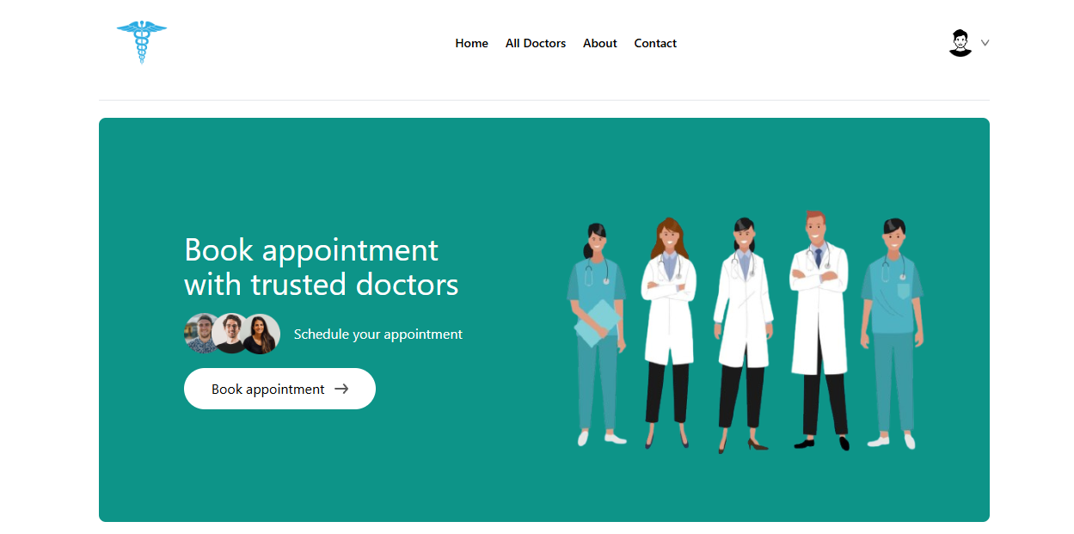
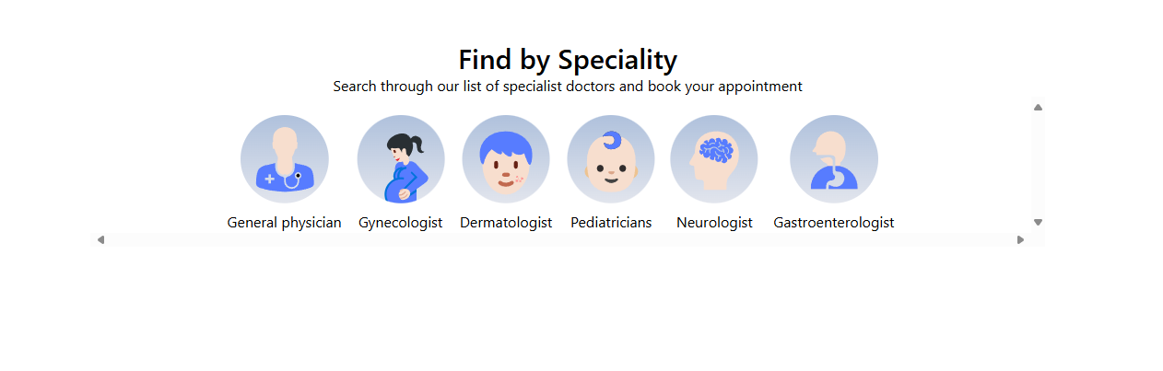
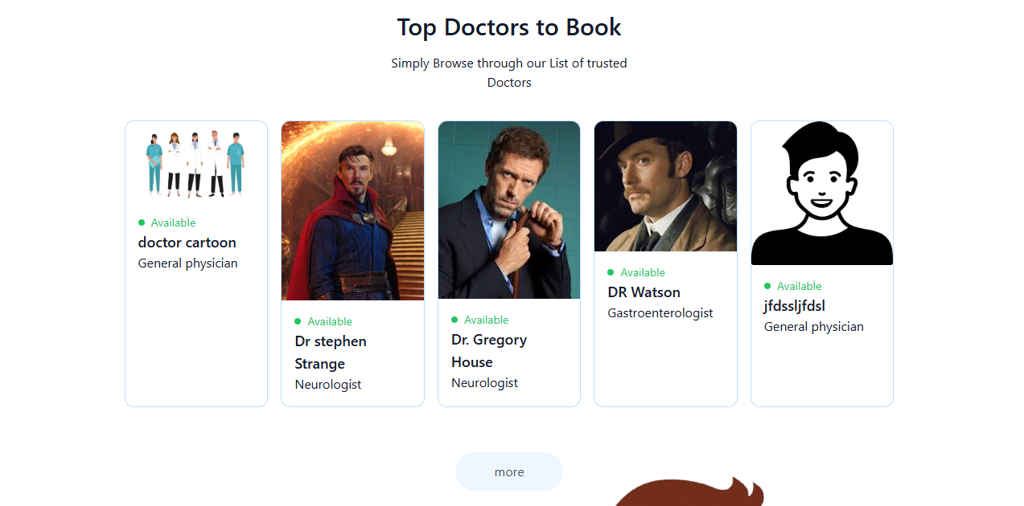

All Doctors
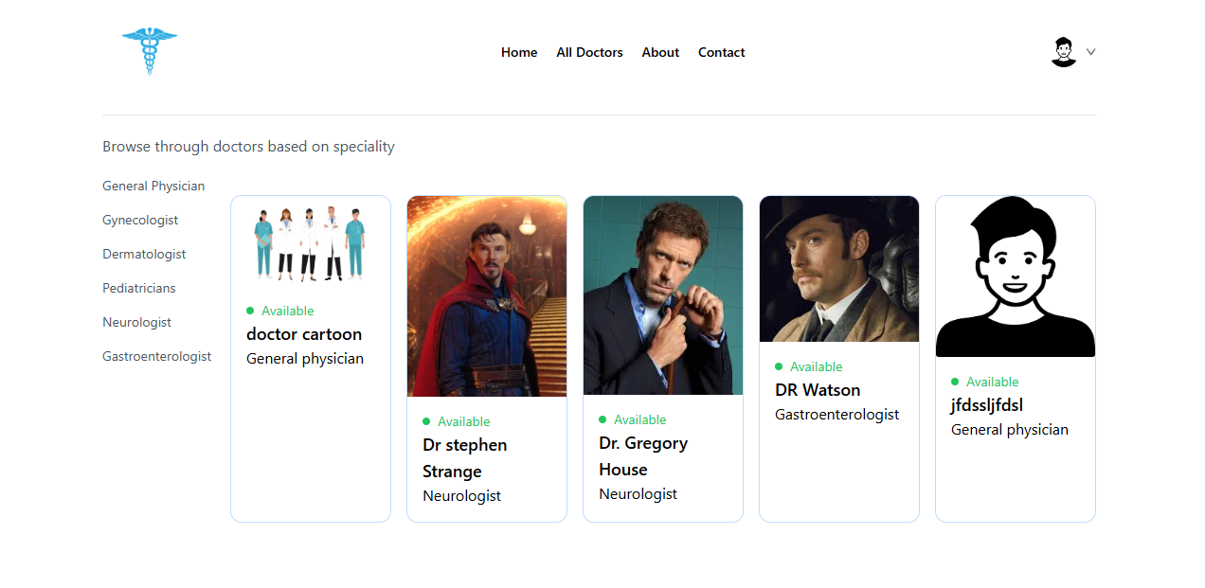
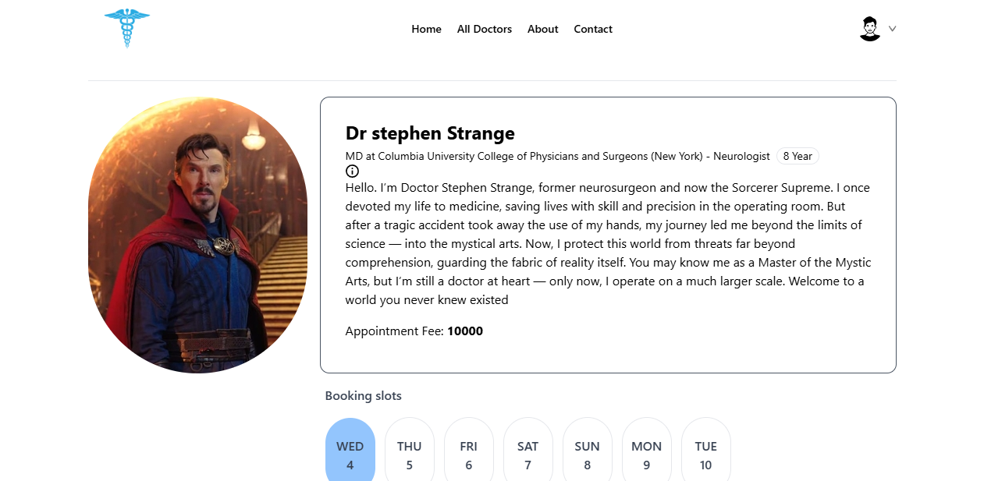
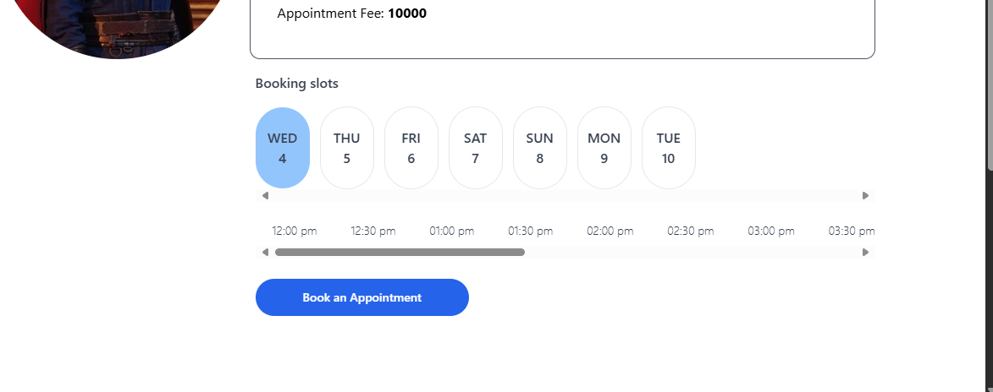

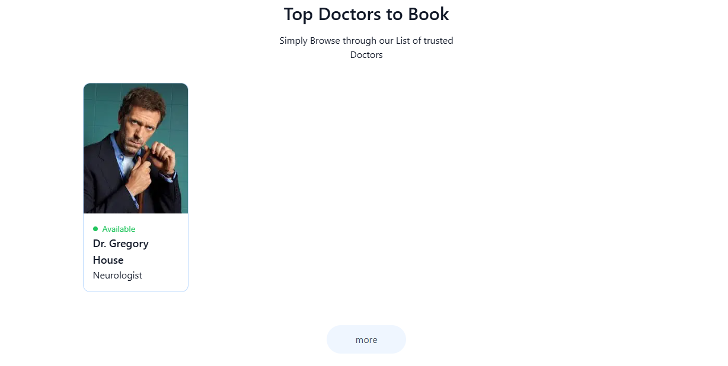

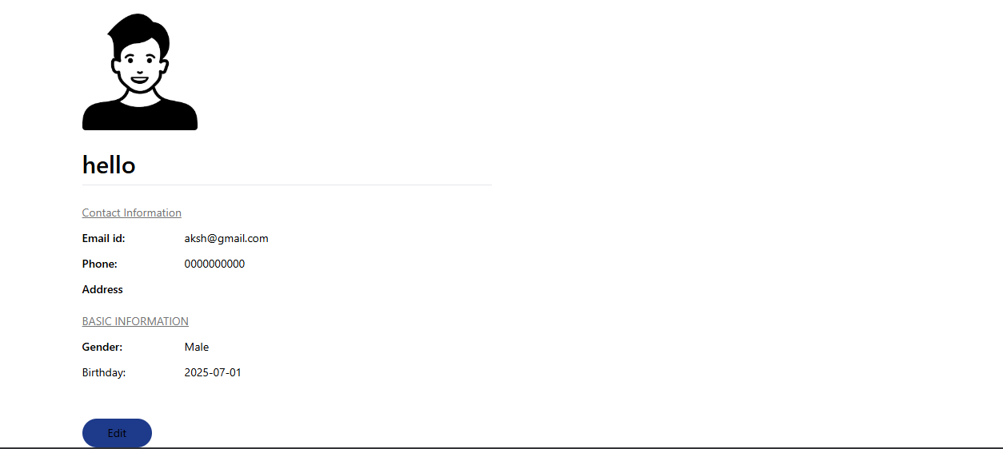

Create Account
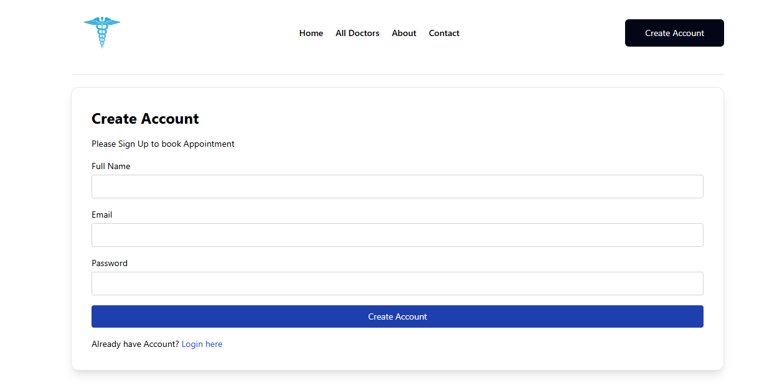
Admin Page
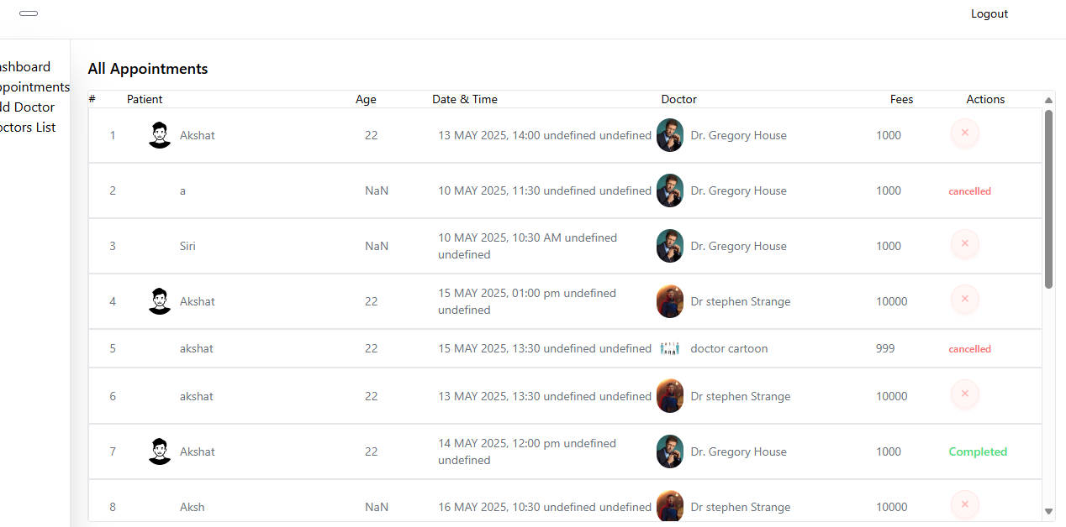
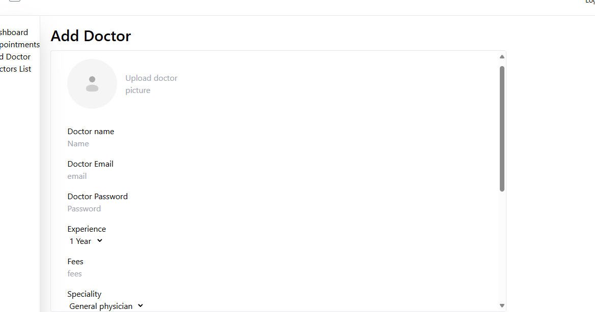
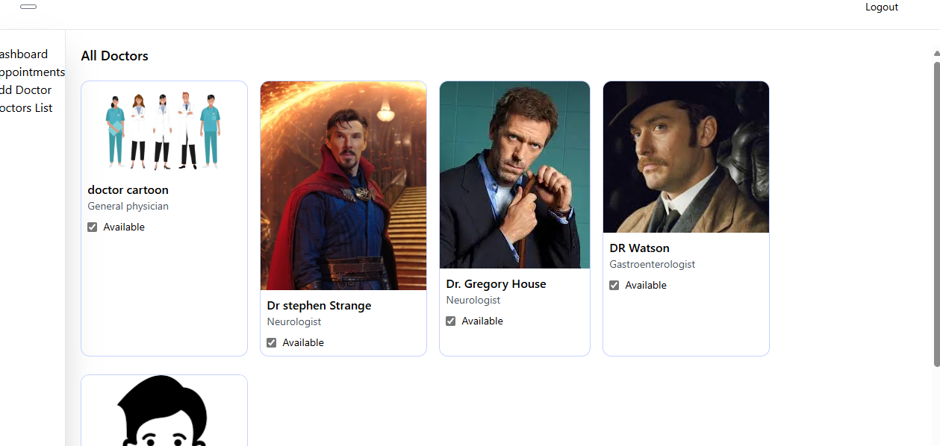
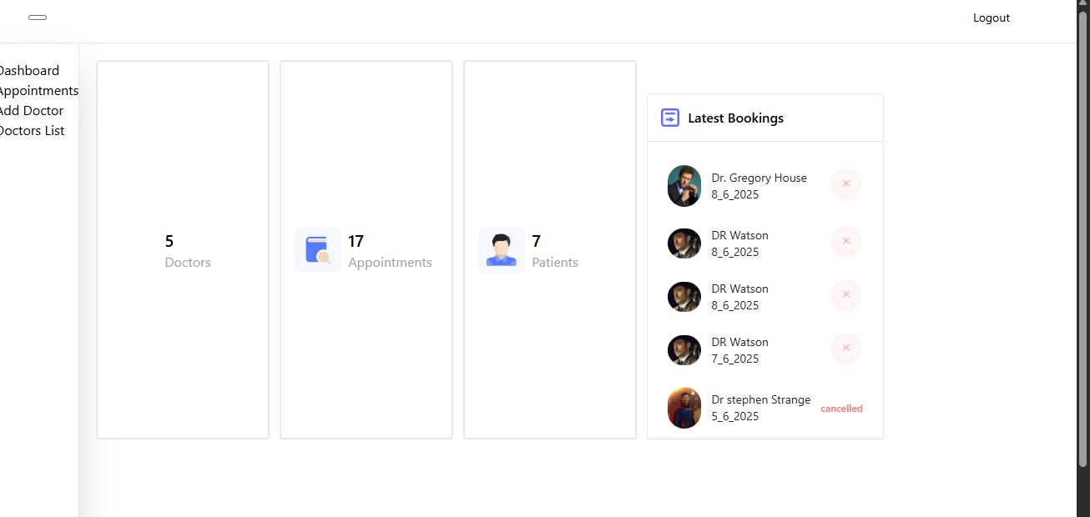
Live Link:- https://healthcare-frontend-2a62.onrender.com/
Admin Link:- https://healthcareadmin-17t9.onrender.com/
Admin Email and Passowrd:- akshatsrivastava2017@gmail.com and 11111111

Code
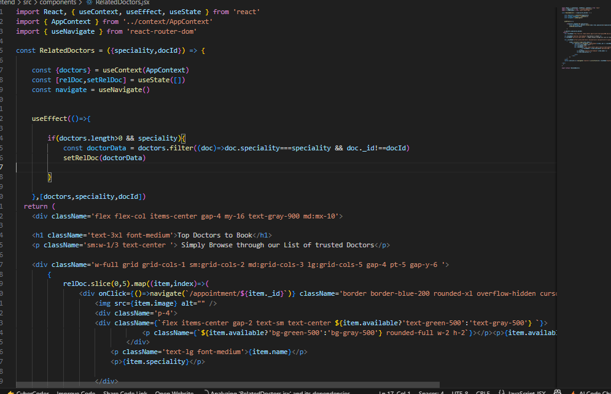
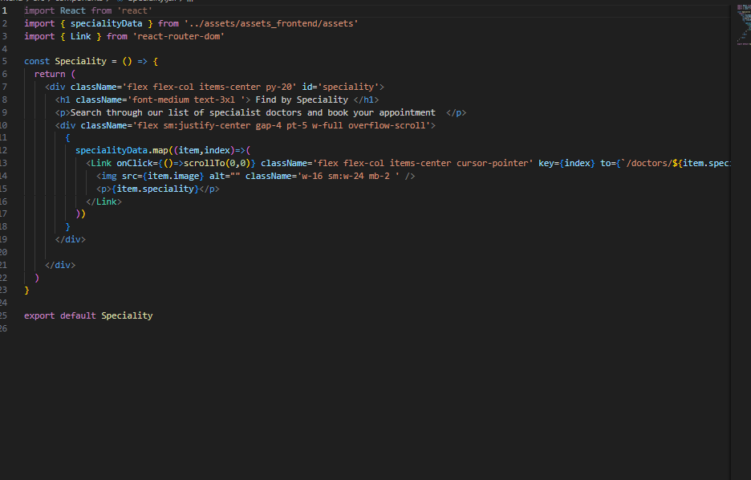
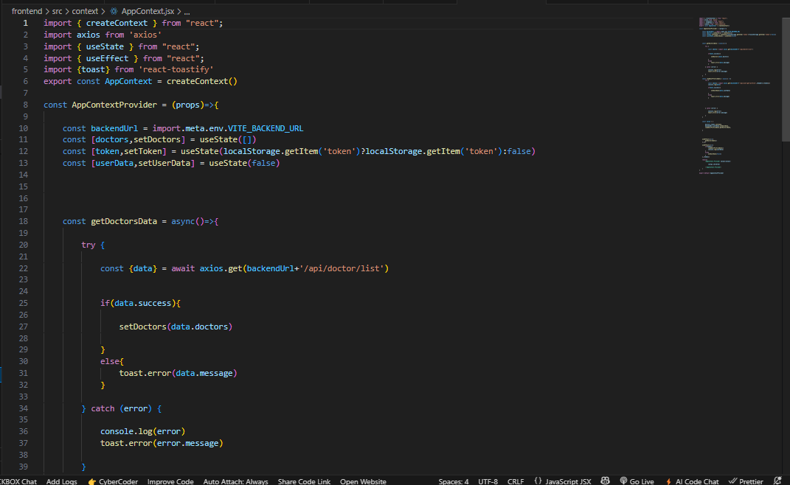
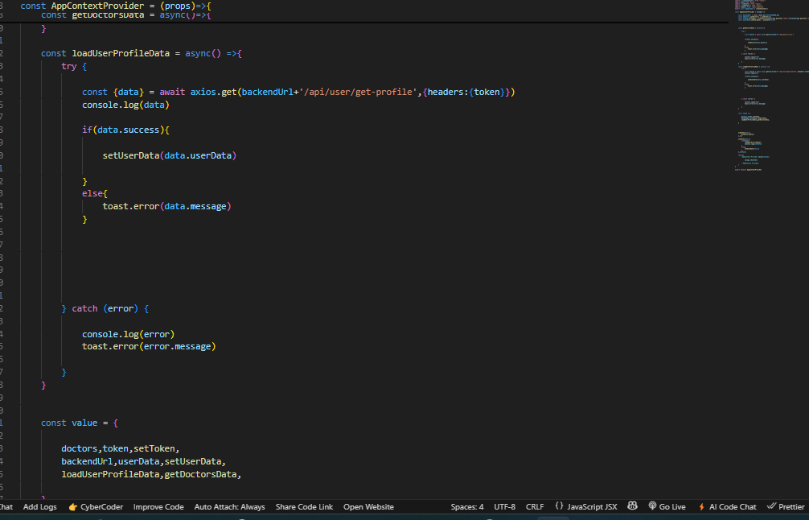
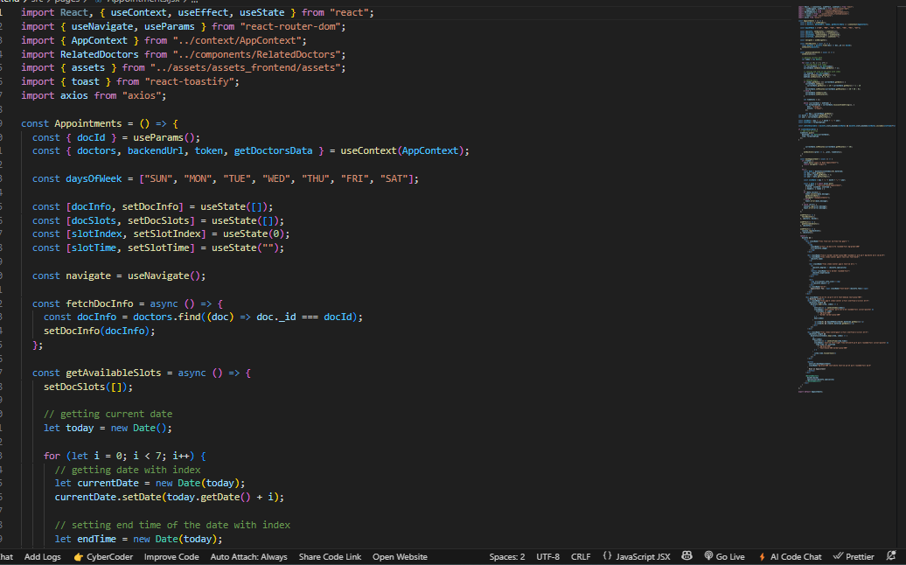
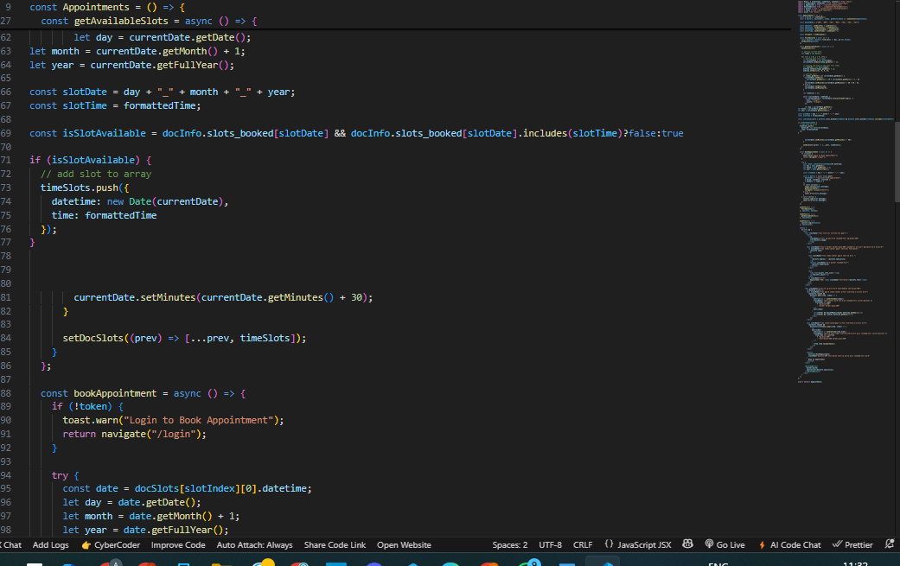
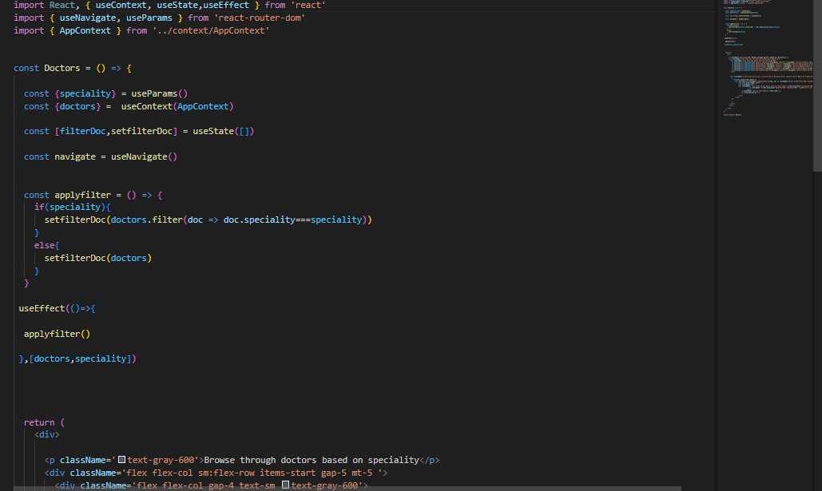
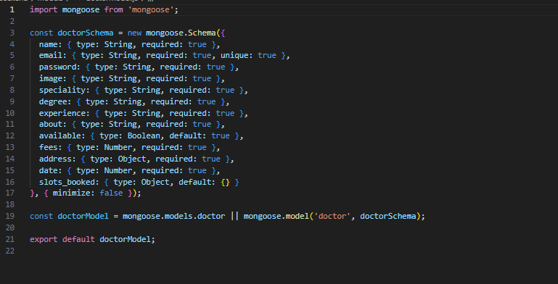
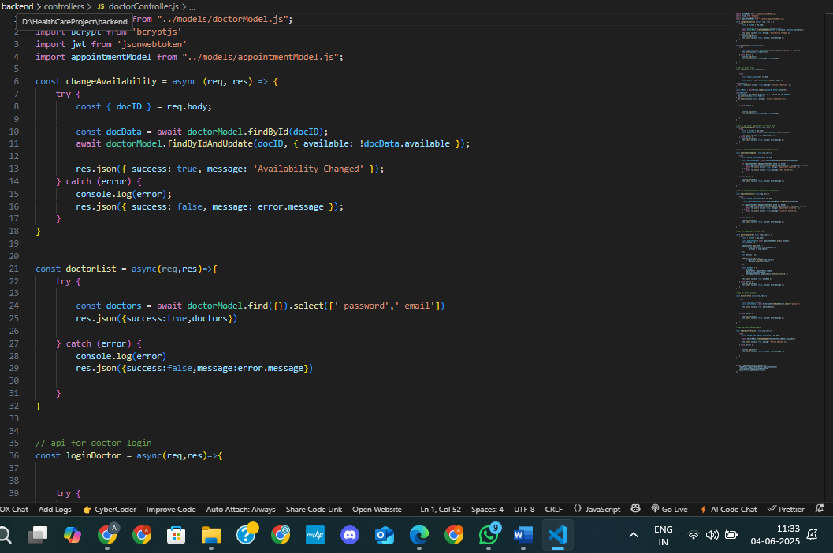
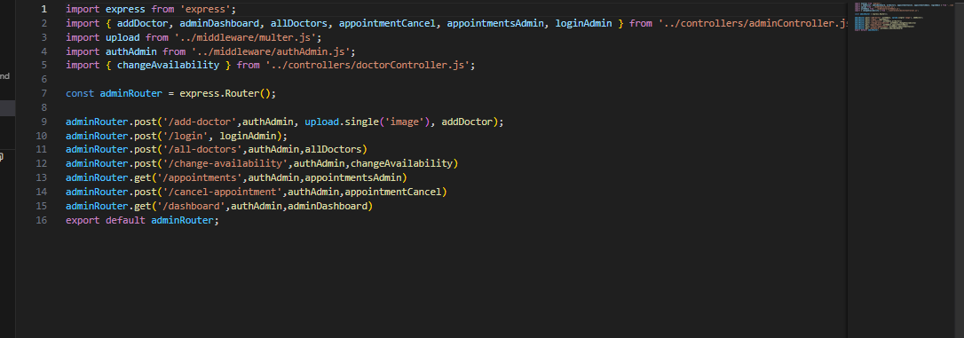
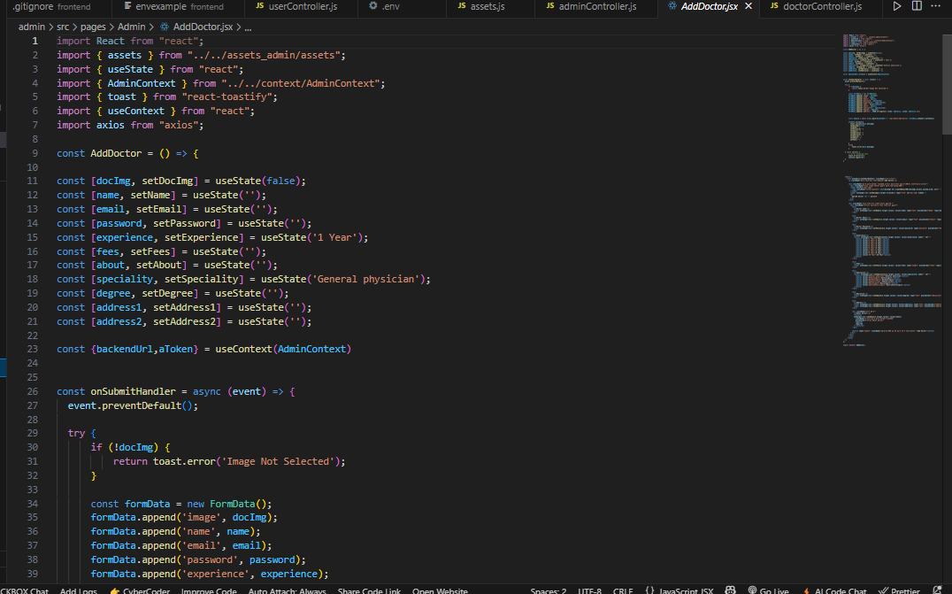
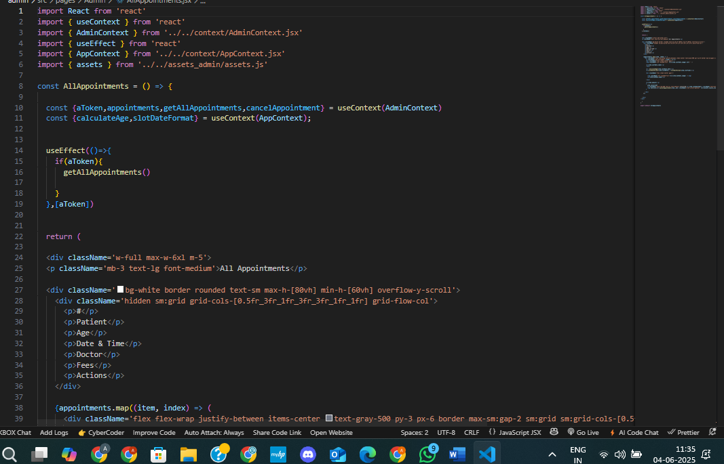
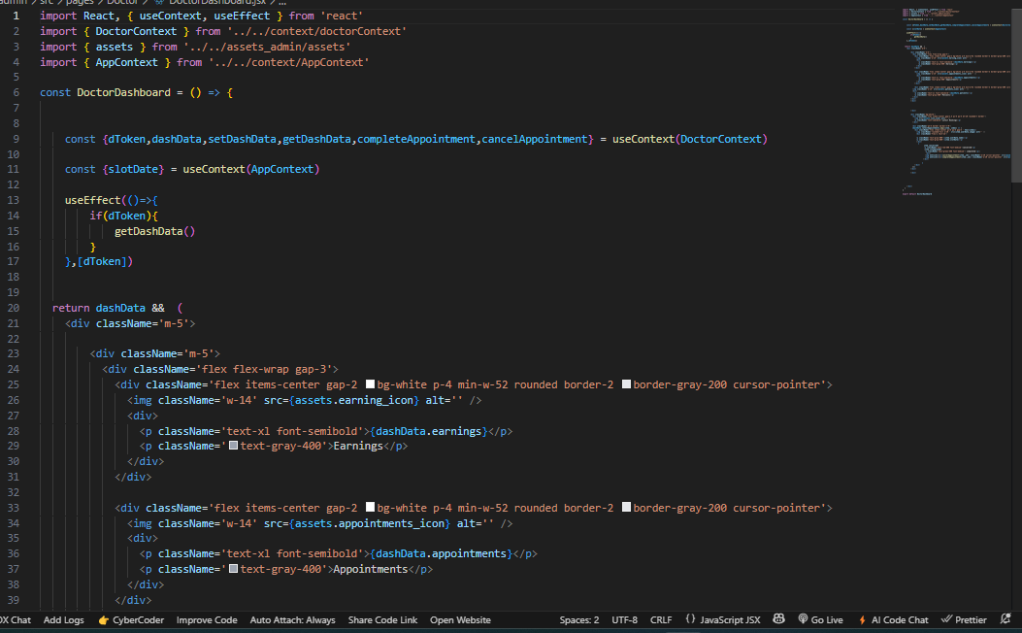
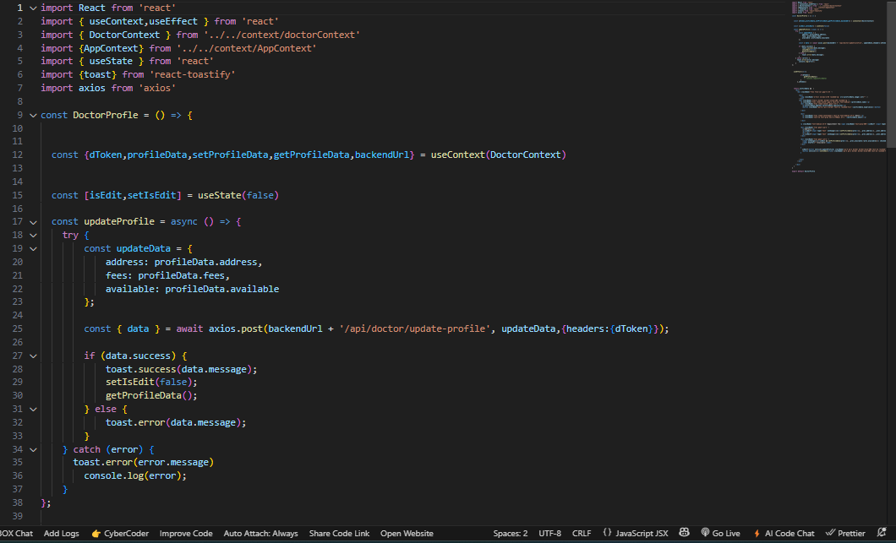

References
[1] M. Tanwar, R. M. Mohapatra, and S. Agarwal, "A review of cloud-based hospital management systems in India," Health Information Science and Systems, vol. 8, no. 1, pp. 1–10, 2020.
[2] A. S. Pantelopoulos and N. G. Bourbakis, "A Survey on Wearable Sensor-Based Systems for Health Monitoring and Prognosis," IEEE Transactions on Systems, Man, and Cybernetics, Part C (Applications and Reviews), vol. 40, no. 1, pp. 1–12, 2010.
[3] J. Kim, H. Park, and Y. Park, "Chatbots and conversational agents in healthcare: A review of the current landscape," Journal of Biomedical Informatics, vol. 93, 2022.
[4] R. Haque, S. Miah, and J. Hasan, "AI-based medical assistant chatbots: Comparative analysis and design framework," Health Technology, vol. 11, no. 2, pp. 359–372, 2021.
[5] A. Razzak, S. Imran, and G. Xu, "Big data analytics for preventive medicine," Neural Computing and Applications, vol. 32, no. 9, pp. 4417–4451, 2020.
[6] T. Loh and K. H. Tan, "WebRTC-based video communication in healthcare: A feasibility study," Telemedicine and e-Health, vol. 24, no. 8, pp. 596–602, 2018.
[7] Twilio Inc., "Twilio Programmable Video," [Online]. Available: https://www.twilio.com/video
[8] M. Vidal-Alaball et al., "Telemedicine in the face of the COVID-19 pandemic," Atención Primaria, vol. 52, no. 6, pp. 418–422, 2020.
[9] NIST, "Recommendation for Encryption: AES," National Institute of Standards and Technology, FIPS PUB 197, 2001.
[10] European Union, "General Data Protection Regulation (GDPR)," 2018.
[11] Google Cloud, "Speech-to-Text API Documentation," [Online]. Available: https://cloud.google.com/speech-to-text/docs

Plagiarism Report
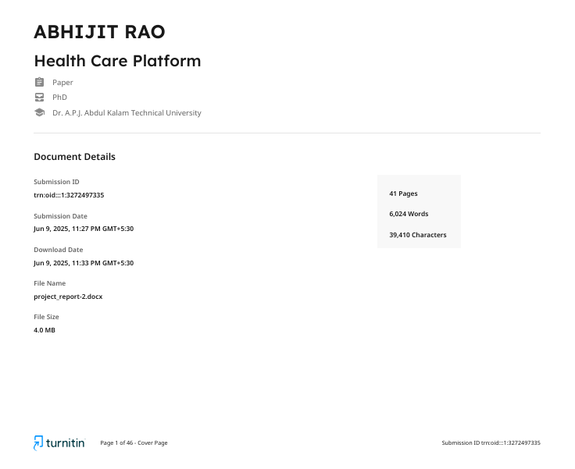
Fig A.1: Plagiarism Report
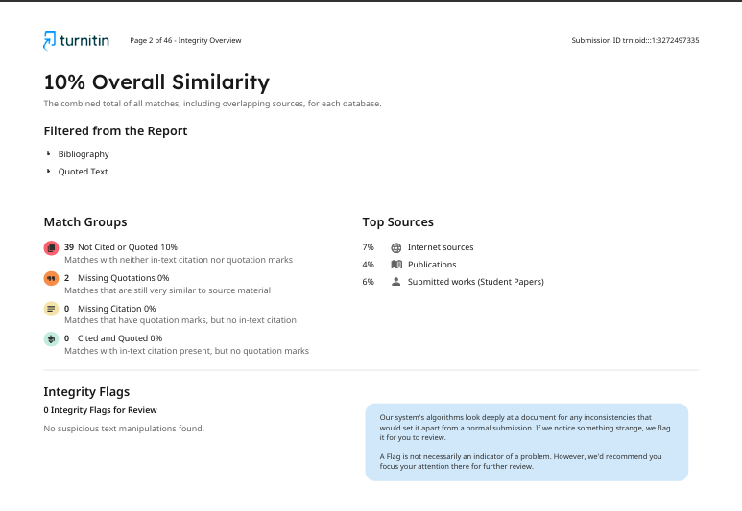
Fig A.2: Plagiarism Report

